Experiment4

**Subject Name: AWS Solution Arch. Lab Subject Code: CSH- 686**

**Aim of the experiment:** To create VPC, Gateways, Route tables,NACs.

**Steps of Procedure:**

1. Go to **VPC**.

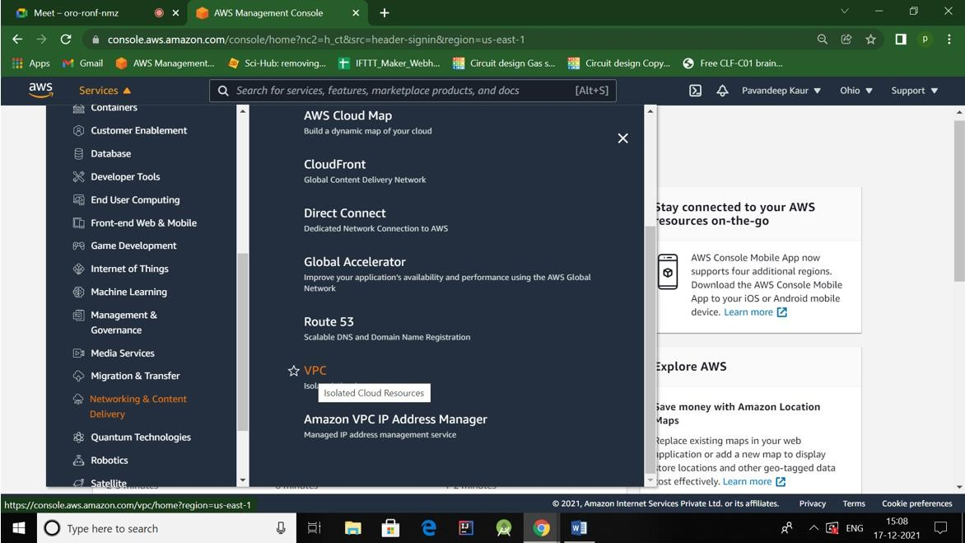

1. Under Your VPCs, click **Create VPC**.

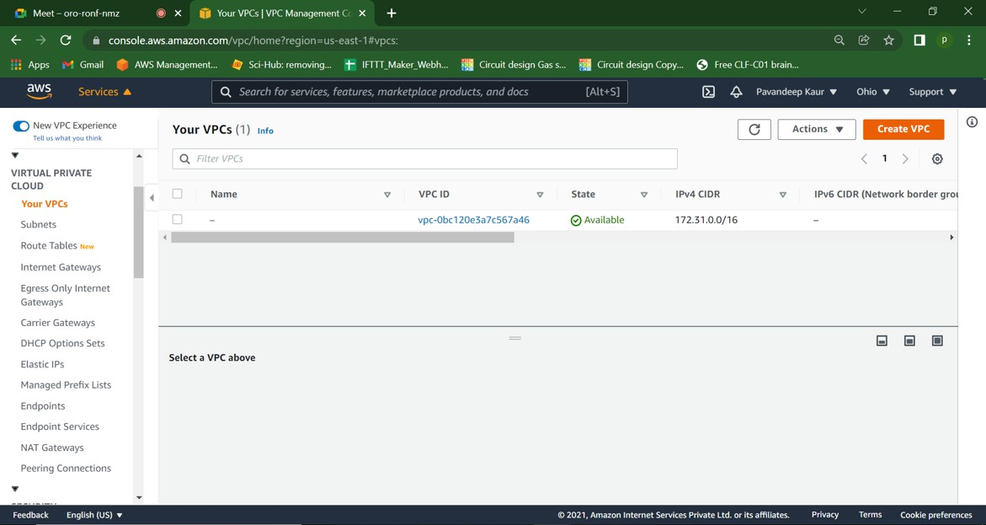

1. Create VPC with name **MyFirstVPC** and NID=**192.168.0.0/16**

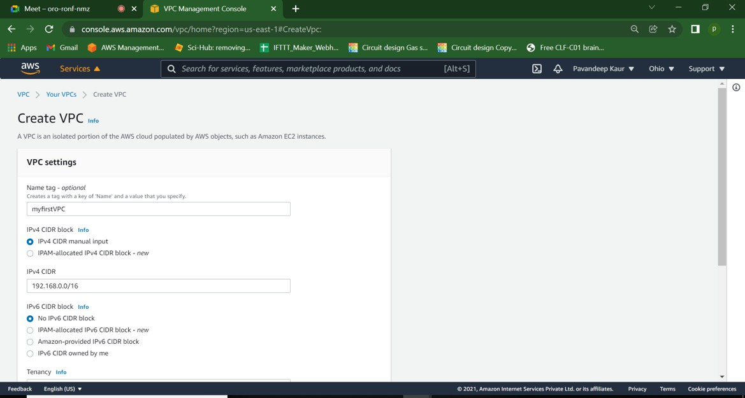

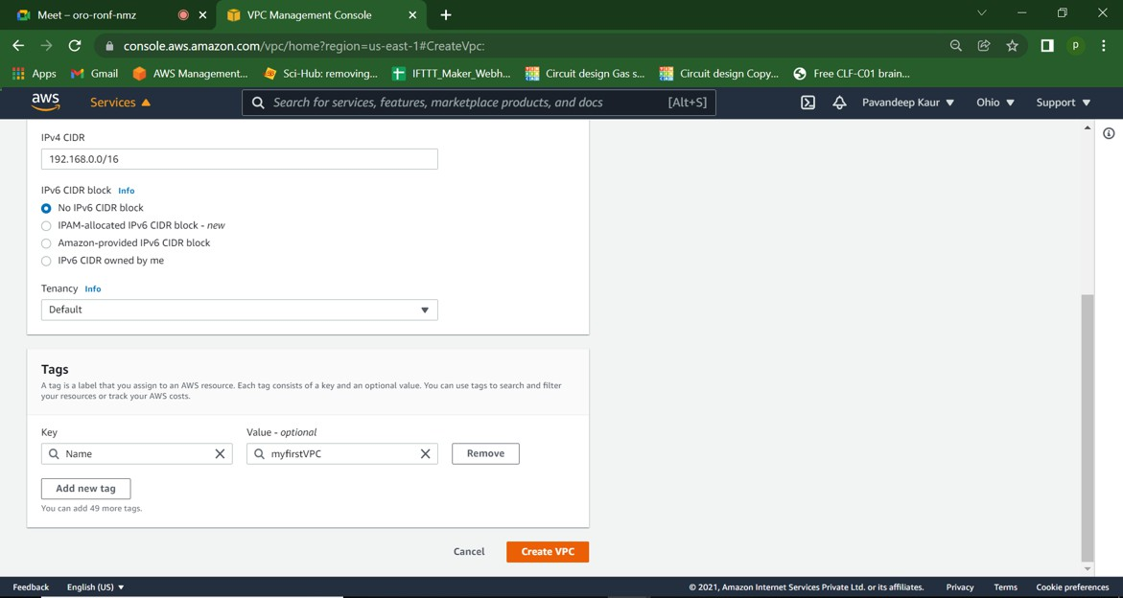

1. Create first subnet,name=**mypublicsubnet**,andIP=**192.168.1.0/24**,AZ=**us-east-1a**

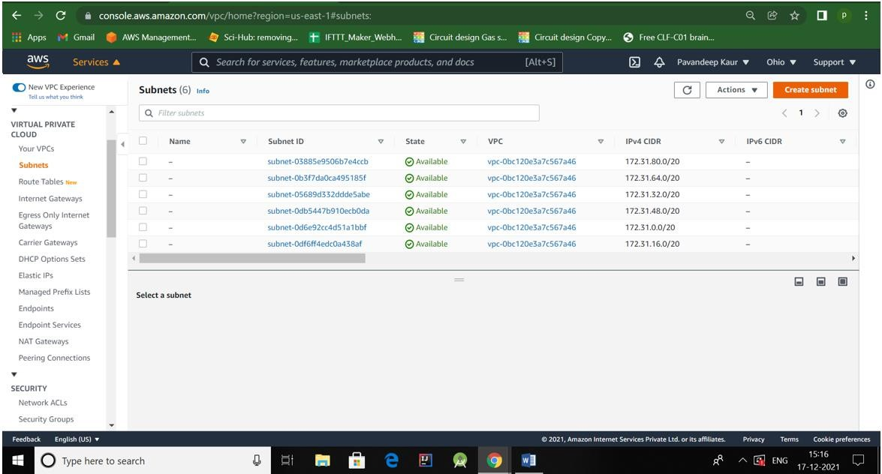

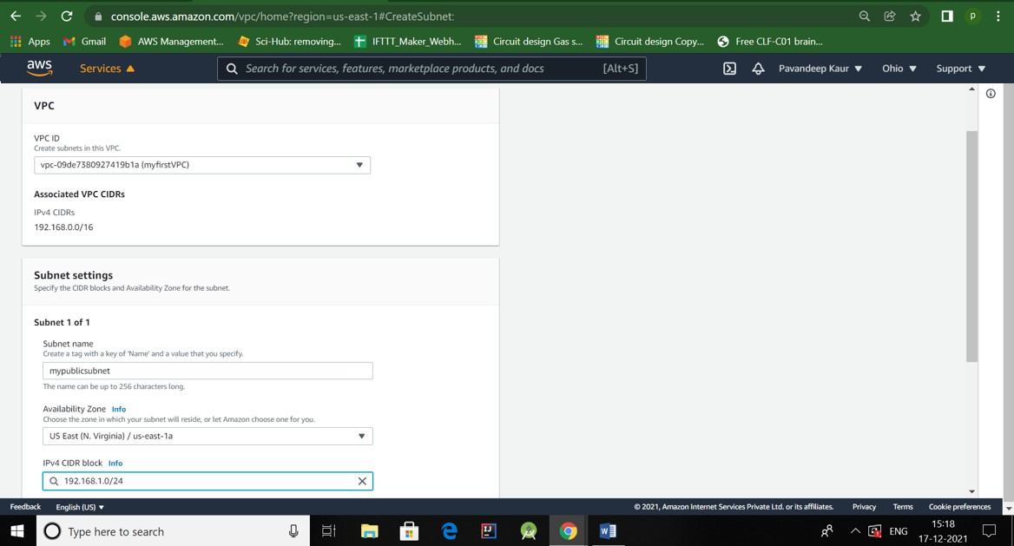

1. Click add new subnet to add second subnet, name=**myprivatesubnet**, IP=**192.168.2.0/24**, AZ=**us-east-1b.**

Then click **Create subnet.**

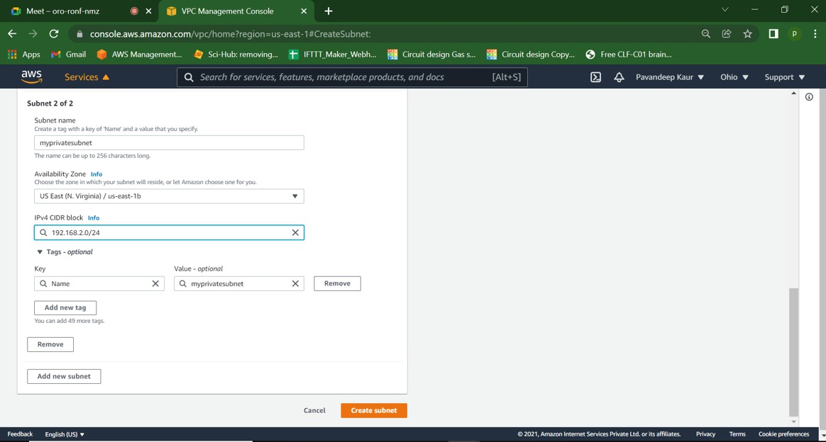



1. 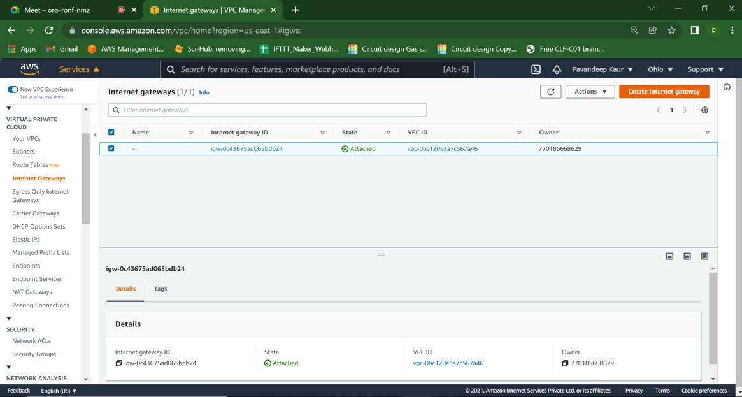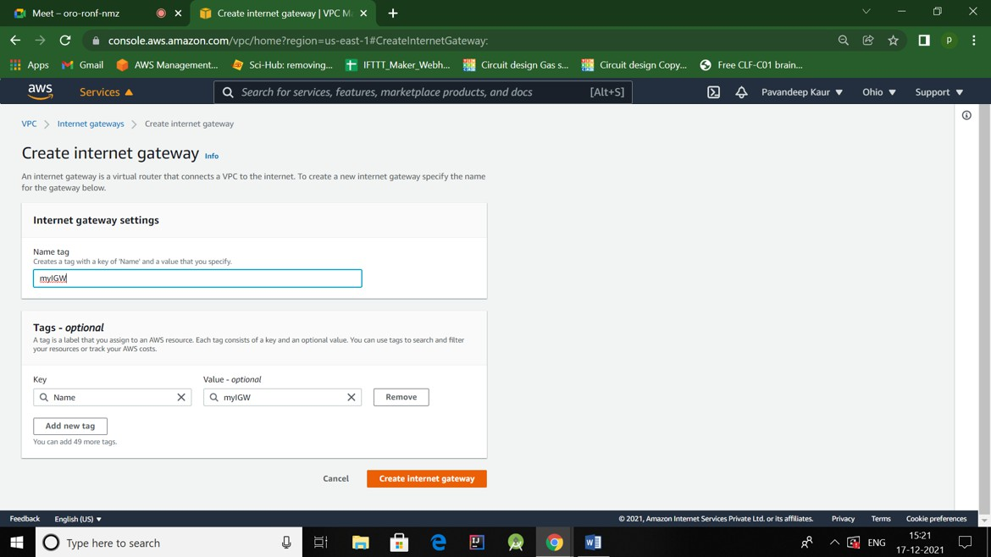Go to Internet Gateways, click on Create InternetGateway,(**name= myIGW**).
2. Attach Internet Gateway to VPC.

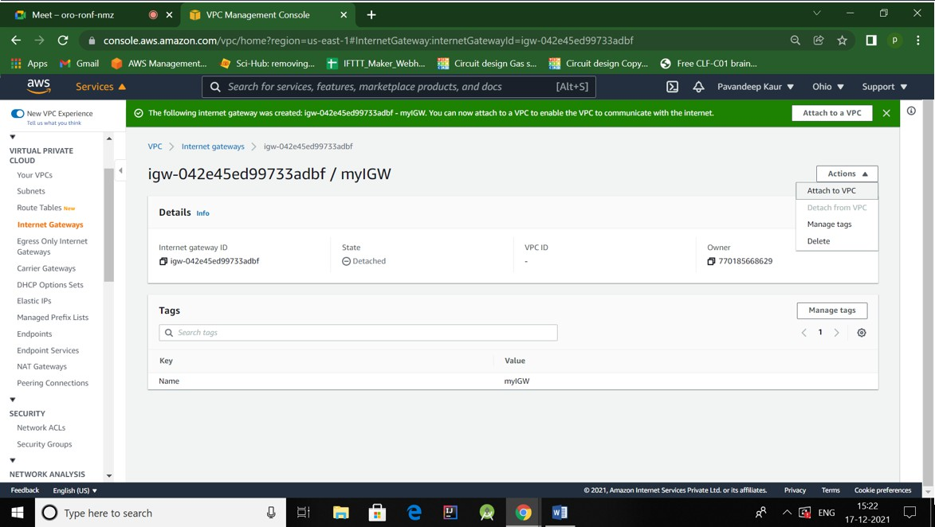

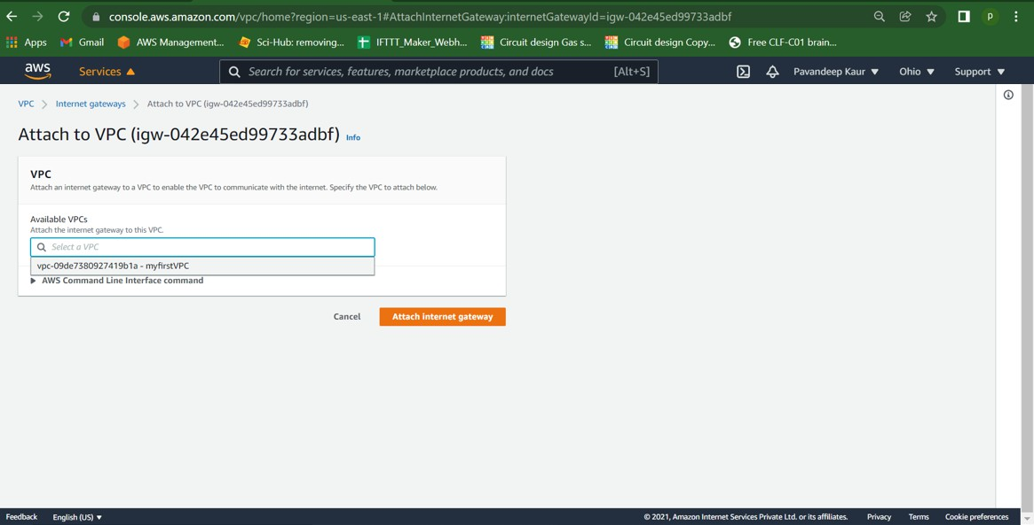

1. Create one **RouteTable** by clicking on **“Createroutetable”.**

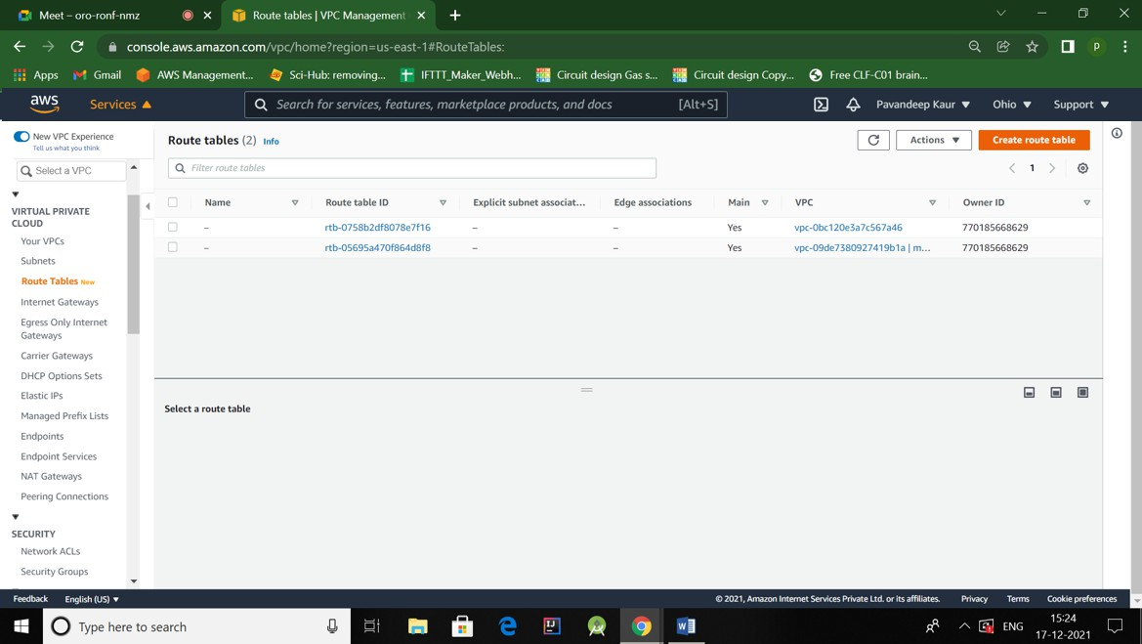

Give a name to the route table like RT1.InVPC,use “myfirstVPC” for this route table.

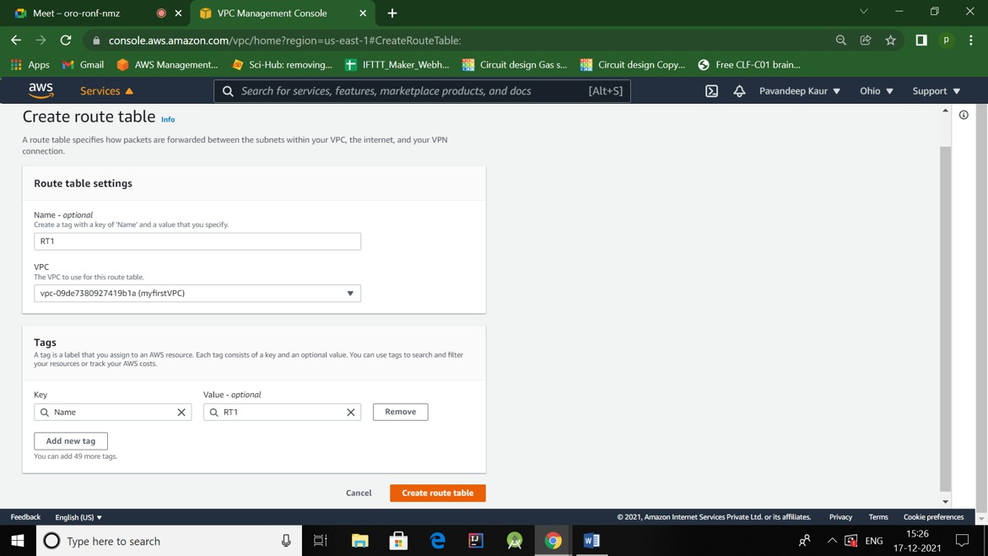

1. Click on Edit subnet associations->**add only public subnet**

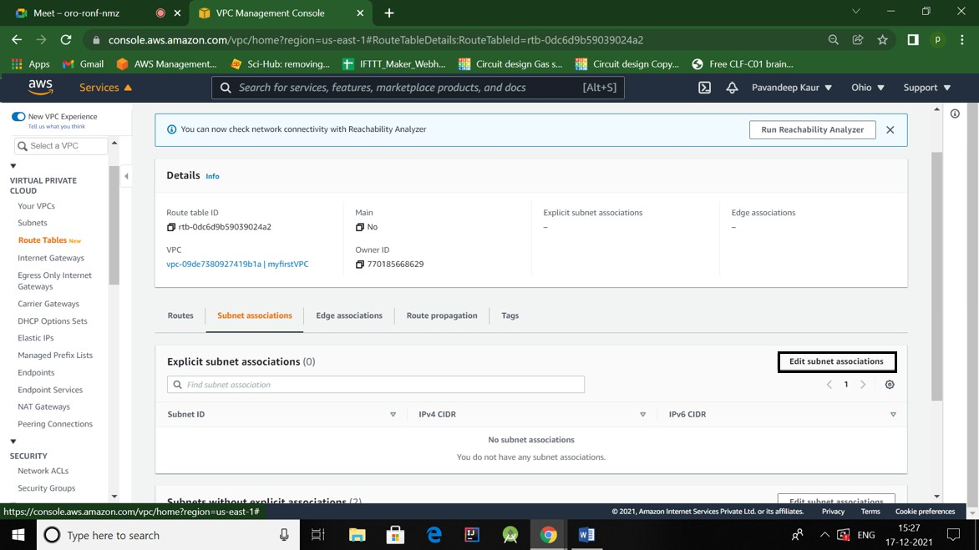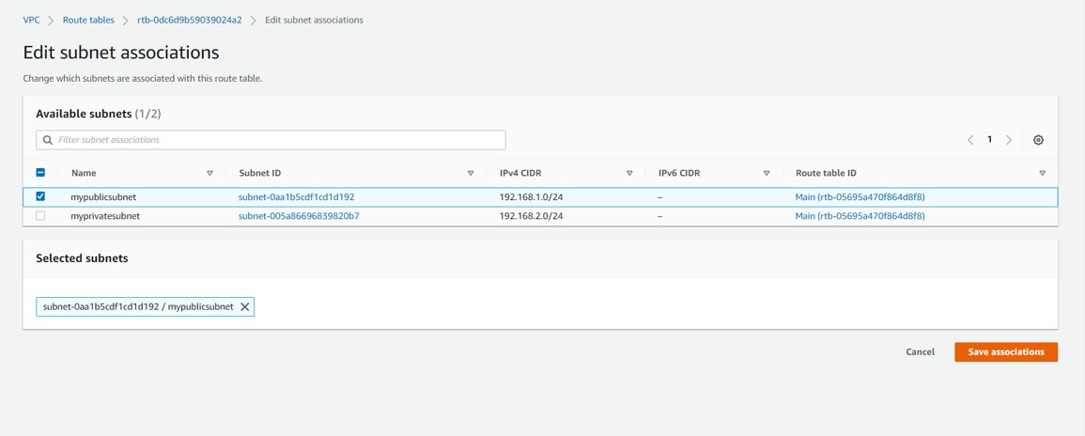

1. In Routes, go to “edit route”, **addroute0.0.0.0/0**,target=myIGW.

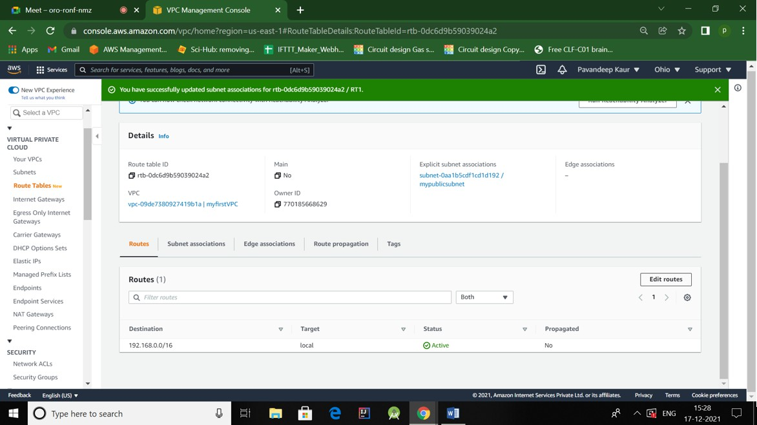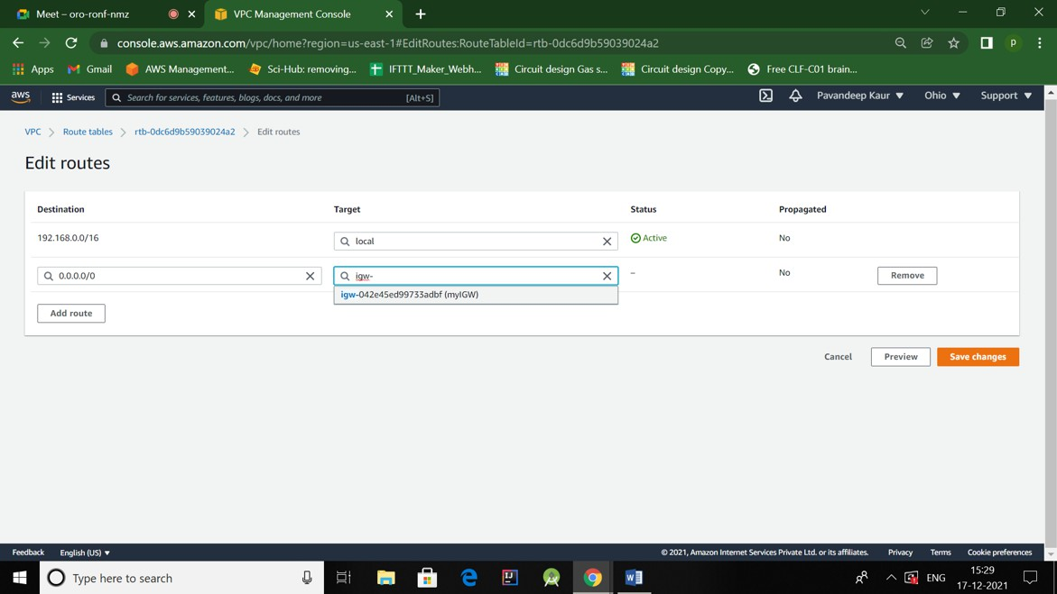

1. Create**NATgateway**.

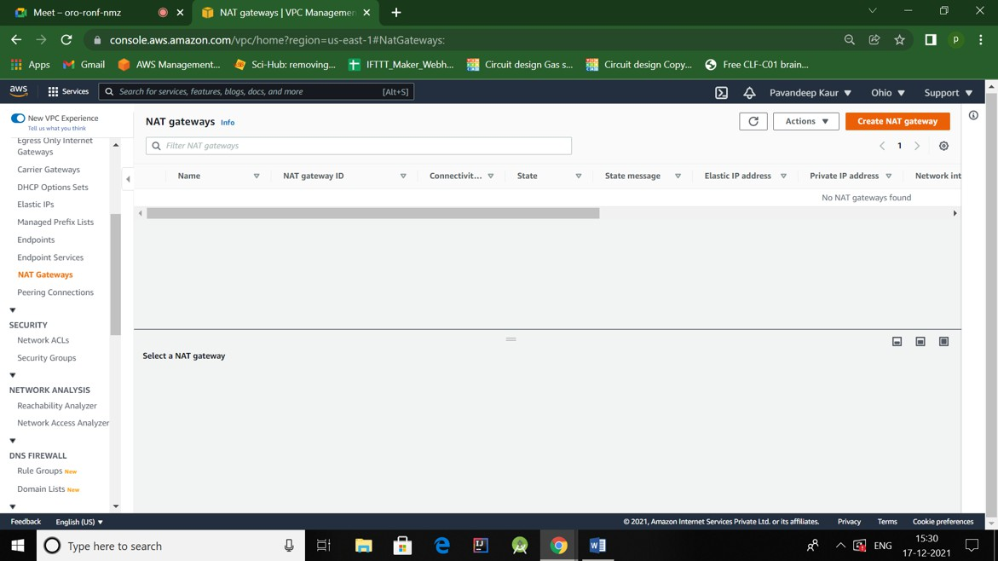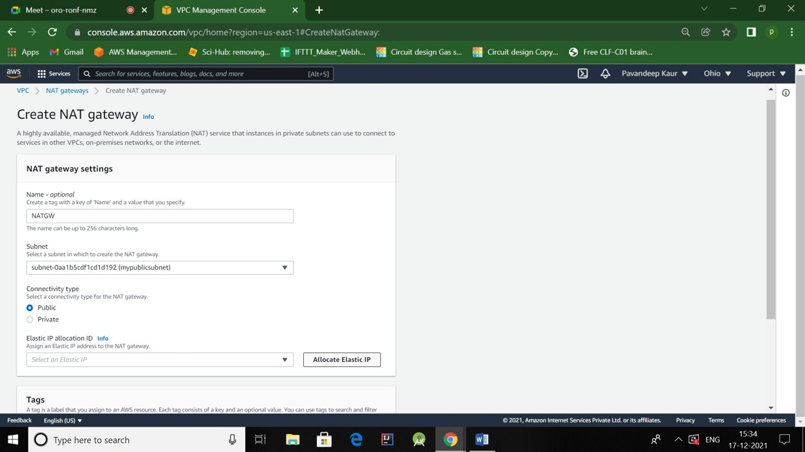

Nameitas:- **NATGW**. Selectpublicsubnet,andconnectivitytypeshouldalsobepublichere.Click **allocate elastic IP.**

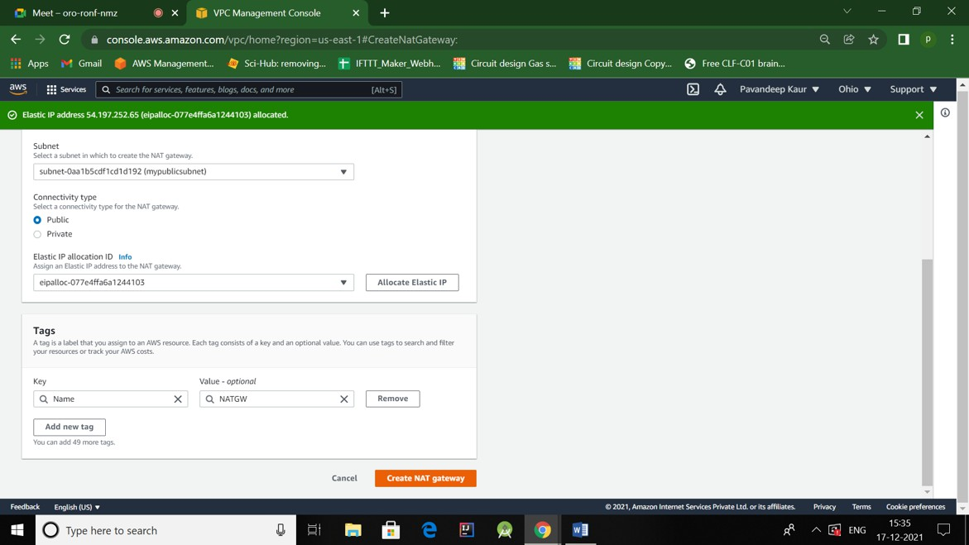

1. Insameway,Create anotherroutetable,nameitas**RT2,**editsubnetassociations-> addonlyprivate subnet.
2. InRoutes,**addroute0.0.0.0/0**,andthistimetargetshouldbeNATgateway.

# Createec2publicinstance:

1. LaunchAmazonLinux instance.

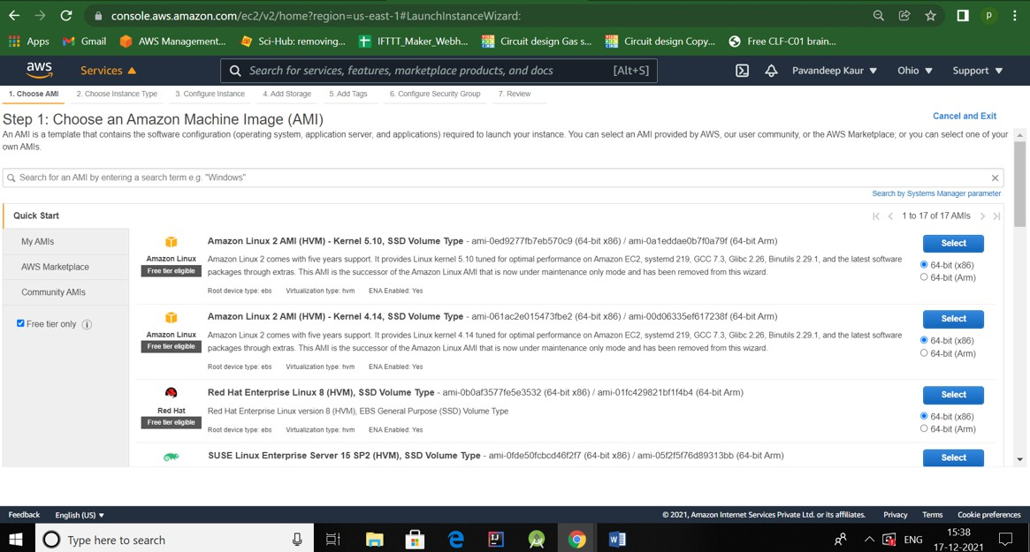

1. Launchinstance using **myfirstVPC**,use**public**subnet,autoassignpublic IPshouldbe**enable**.

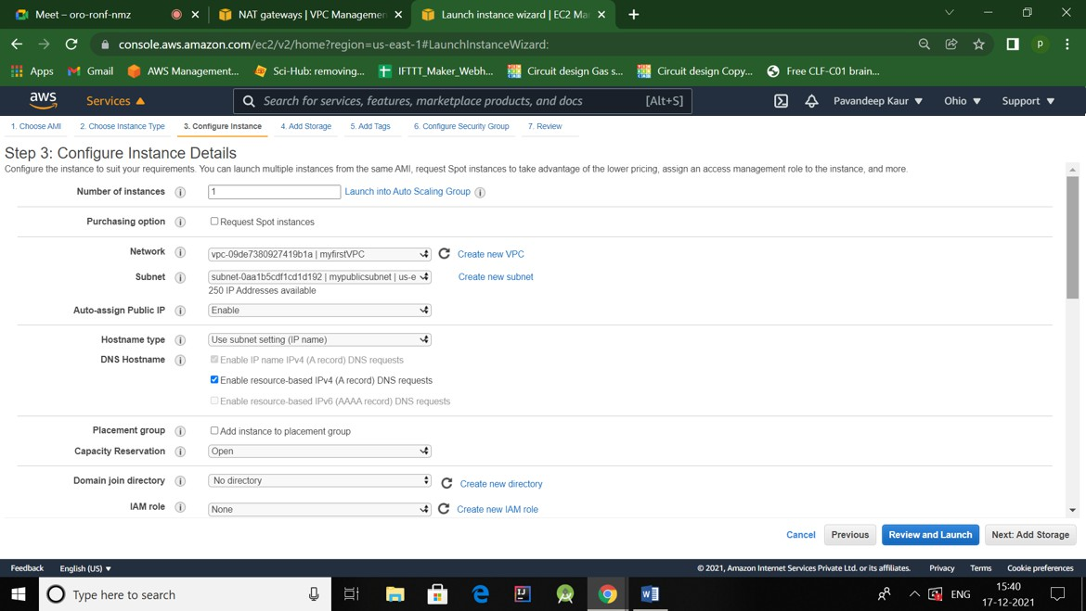



1. Add**tag**Name,**MypublicVM**.

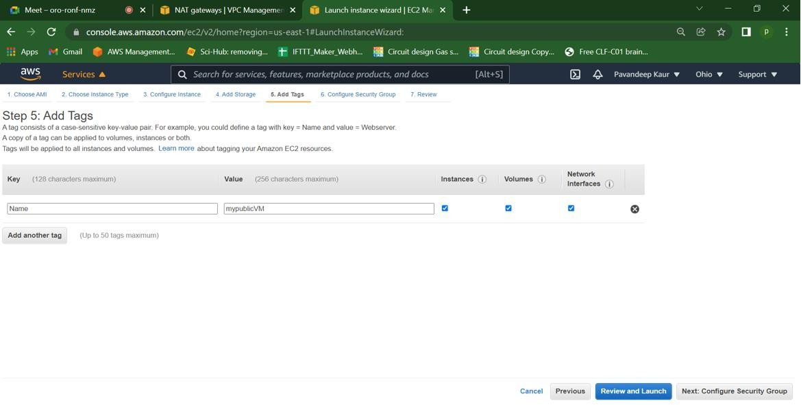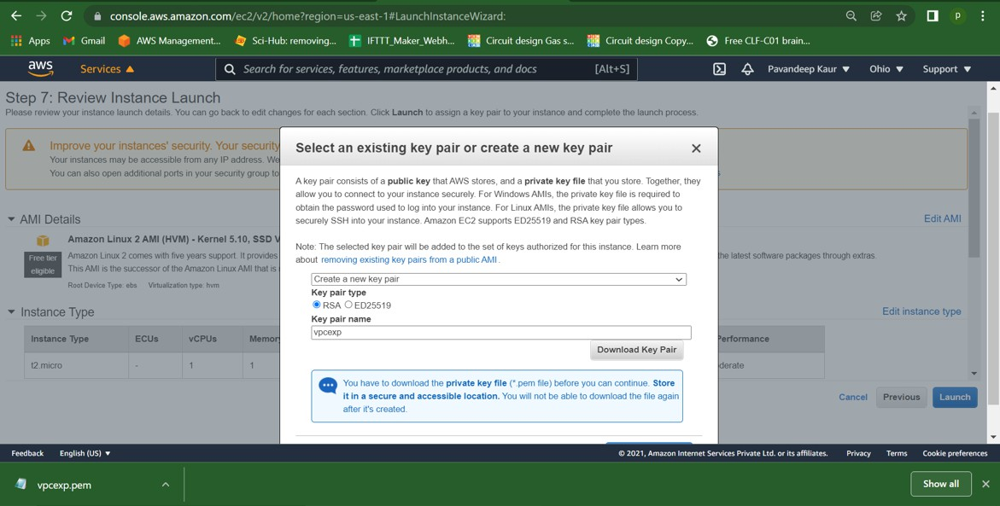

Createnewkey-pair:**vpcexp**

ReviewandLaunch.

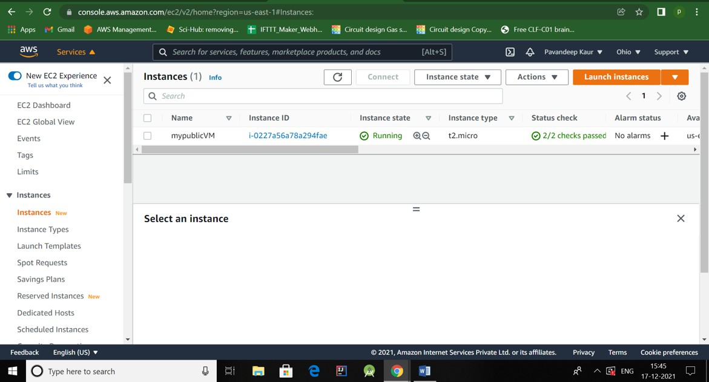

**PublicVMisworking.**

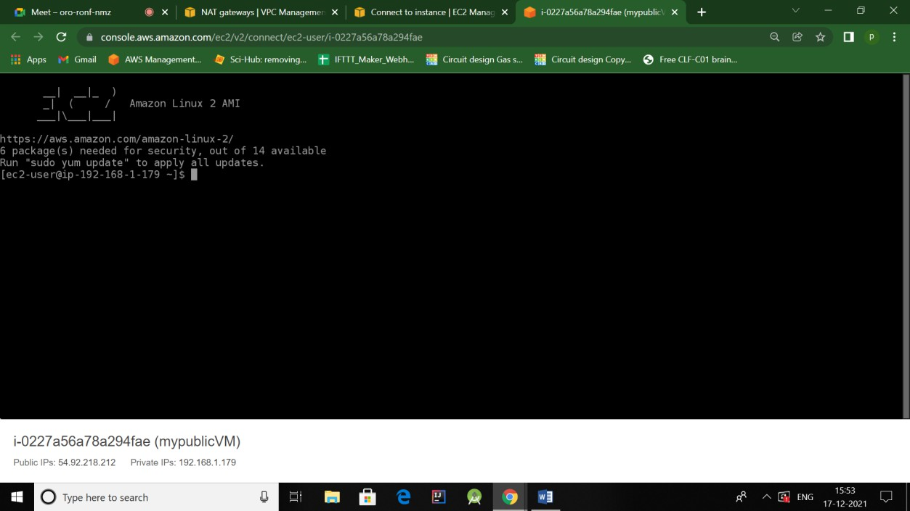

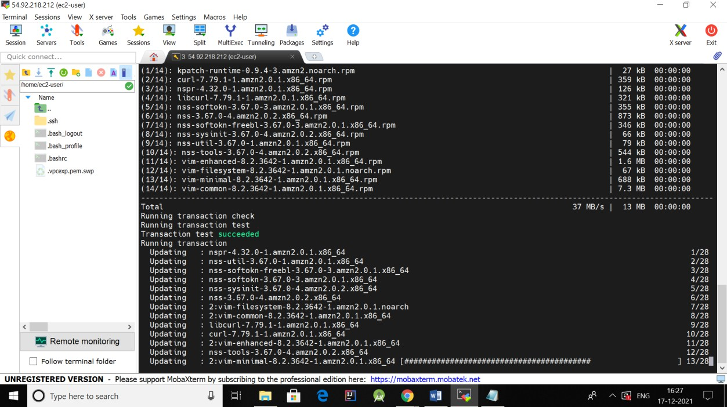

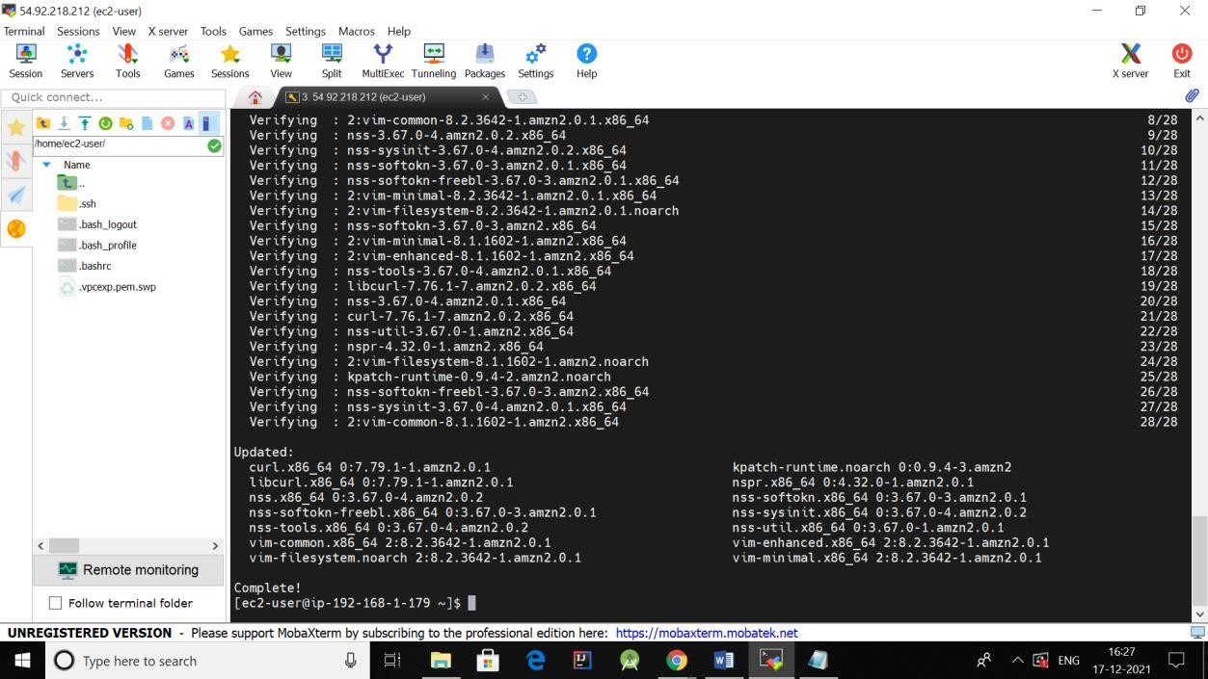

**Createec2private instance:**

Launchinstance usingmyfirstVPC,use**private**subnet,autoassignpublic IPshouldbe**use autoset disable**.

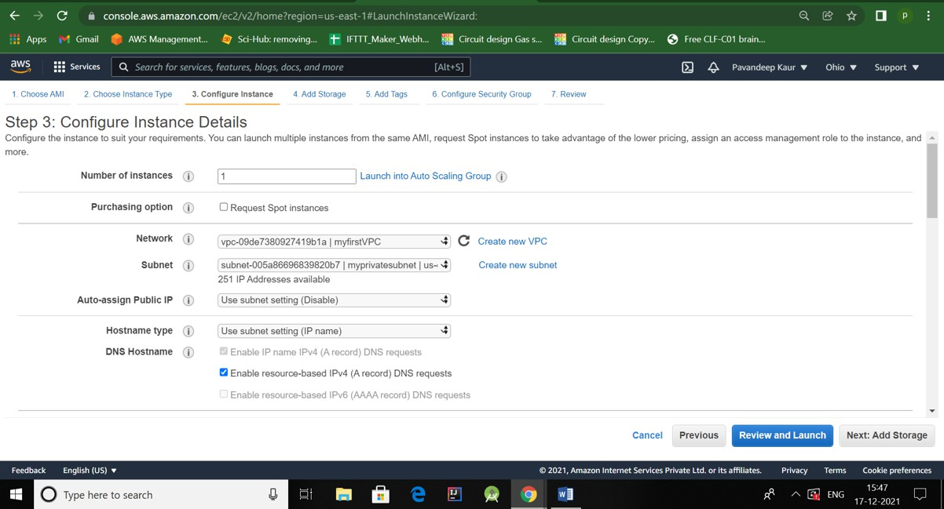

AddtagName,**myprivateVM**.

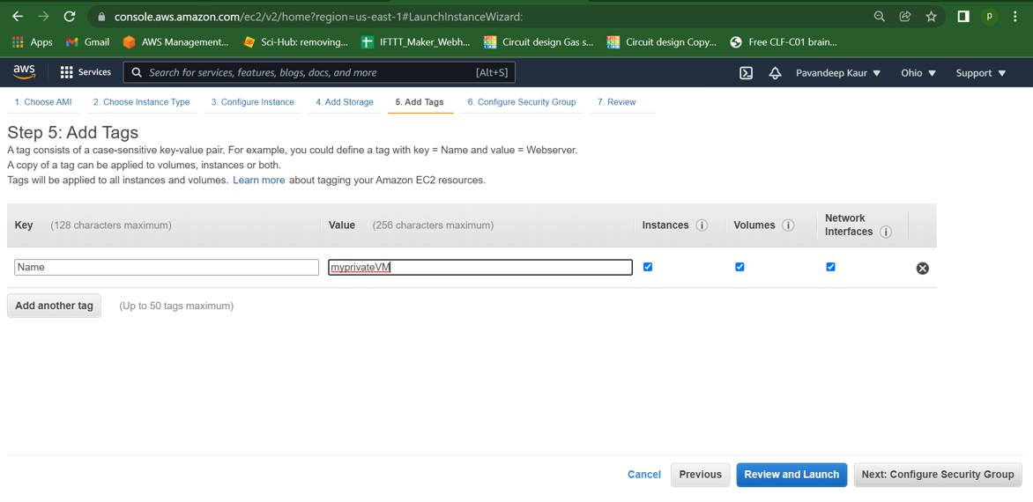

Launch.

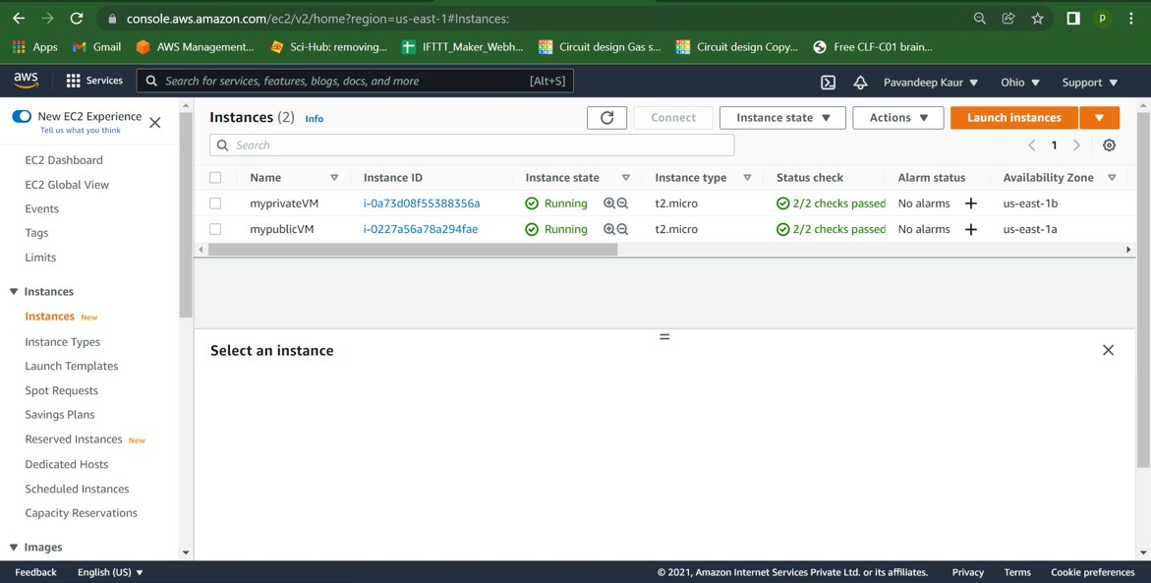

StillwecannotConnectprivateVM,bczthereisnopublicIP.

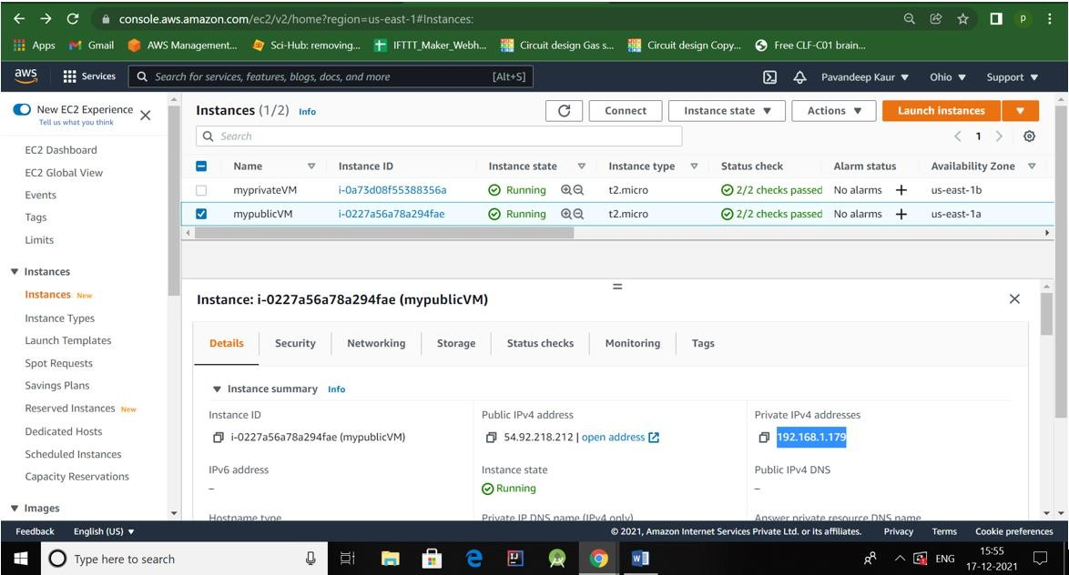

So, goto **myprivatevm**, Security->**securitygroups**.**EditInboundrules**.AddallICMP IPv4,custom= id should be private IP of public VM.

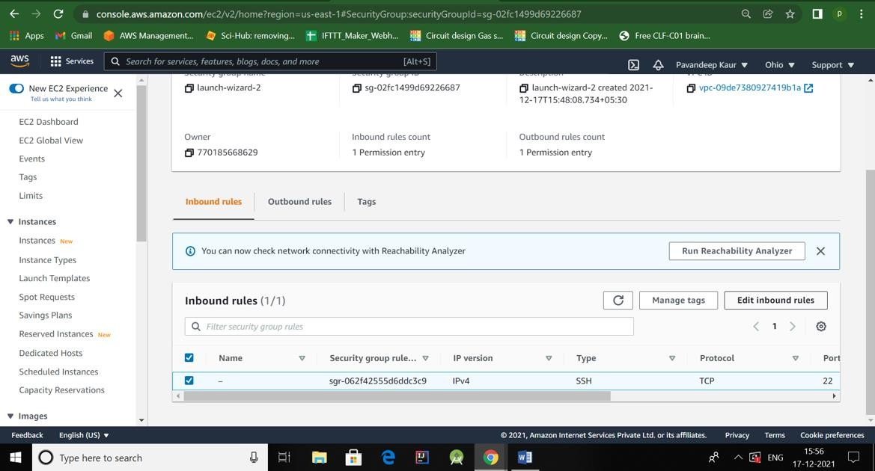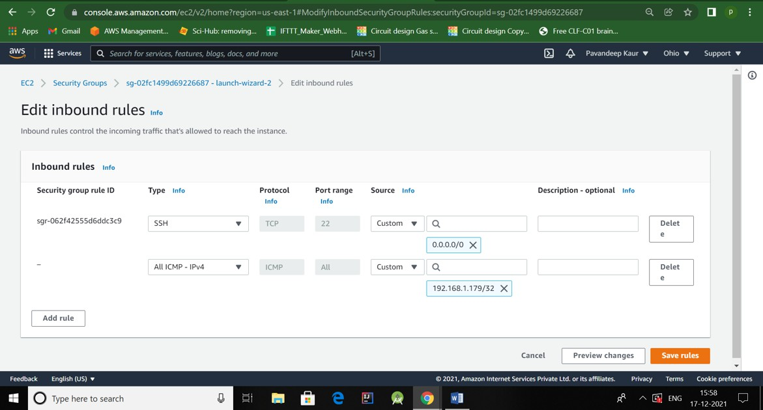

Open**Mobaxterm**,ssh-> hostname=public IPofpublicVM.

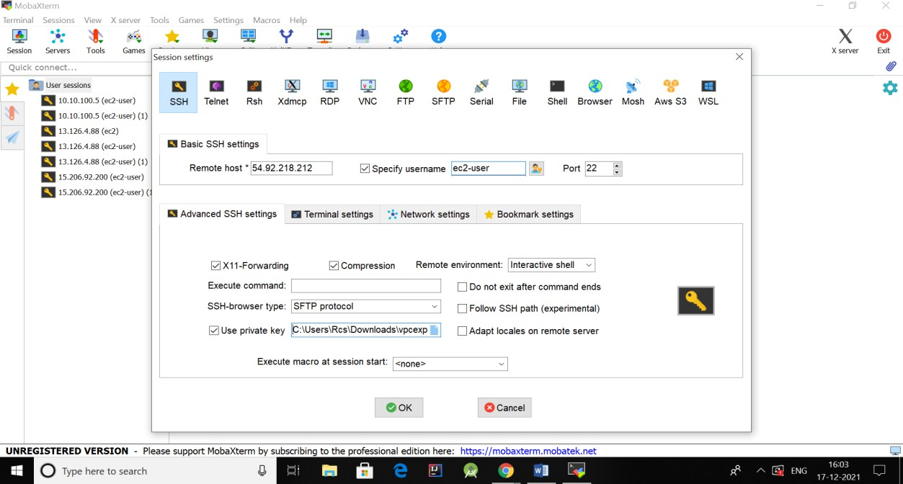

**Ping**privateIPofprivateVM.

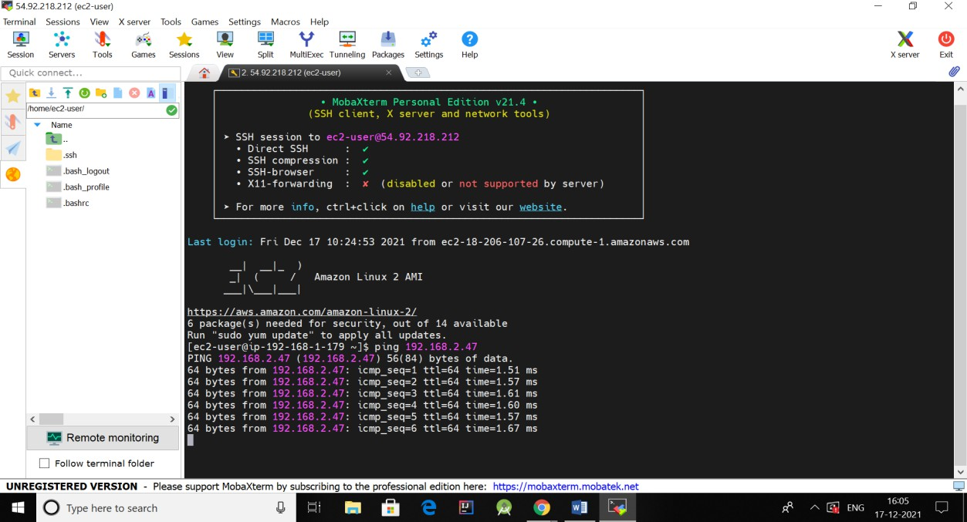

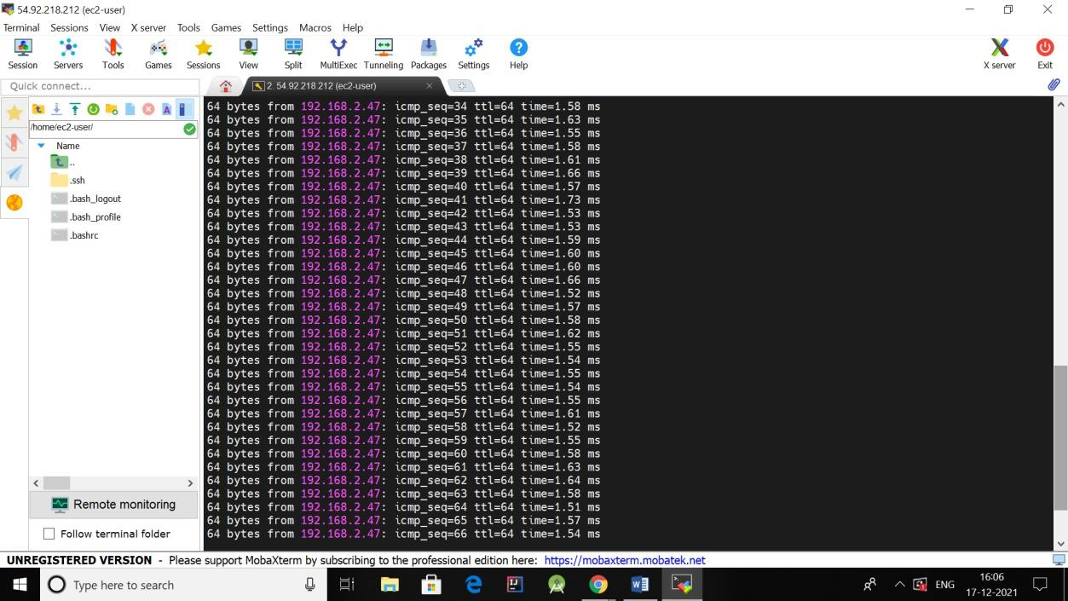

**PrivateEC2instanceisworkingsuccessfully. Weping privateVMsuccessfully.**NowReleaseElasticIP after use.

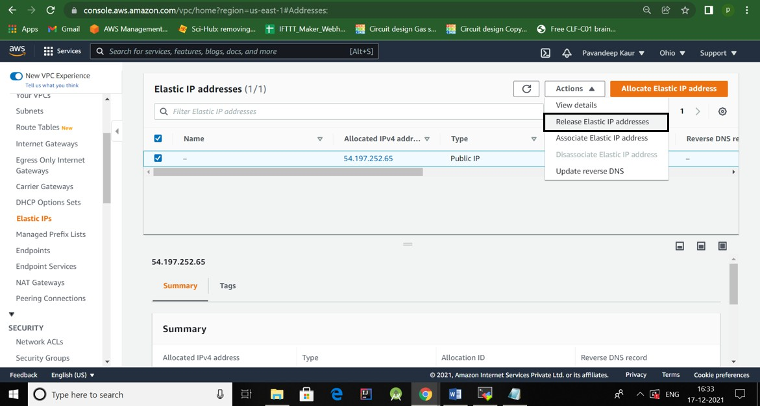



# Learningoutcomes(WhatIhavelearnt):

1. Ilearnt VPC.
2. Ilearnthowto createVPC, howto createsubnets (publicandprivate).
3. IlearntfunctioningofInternetGatewayandNATgateway.
4. Ilearntabout ElasticIP.

**EvaluationGrid(Tobecreatedasper theSOP andAssessmentguidelines bythefaculty):**

|  |  |  |  |
| --- | --- | --- | --- |
| Sr. No. | Parameters | MarksObtained | MaximumMarks |
| 1. |  |  |  |
| 2. |  |  |  |
| 3. |  |  |  |
|  |  |  |  |